Getting to the CORPlaw Office
Directions, Parking, and Check-in Instructions
5 Simple Steps
- Put our address in your phone
- Park near or in the Brickell City Center Building
- Find the WeWork on the 5th Floor within the Brickell City Center Building
- Check-in at the front desk on the 5th floor (not the 1st floor)
- A member of the CORPlaw team will come down to greet you, after you “check-in”

Address | WeWork Brickell City Centre, 78 SW 7th St, Miami, FL 33130
CORPlaw Phone | 1 (833) 545-7526

CORPlaw is housed within WeWork at the Brickell City Centre (“BCC”) building. WeWork is located on the 5th floor of BCC in Downtown Miami. Navigating any downtown area can be a bit tricky. These detailed instructions are meant to simplify things and help you find your way to our office. As always, if you have any questions, please feel free to call us for assistance.

- How do I get to the Brickell City Centre building?

  - Driving from I-95. Whether you’re coming from the north or south, take Exit 1B to US 41 (Southwest 8th Street/Southwest 7th Street). Head down Southwest 7th Street until you see BCC. You can’t miss it.

  - Ridesharing Drop-off. Rideshares like Uber have easy pick-up and drop-off spots for riders. The closet spot to the CORPlaw office would be the Saks Fifth Avenue drop-off/pick-up location.

  - Metro. Hop on the Brickell Loop Metromover and exit at the Brickell City Centre Station (8th Street). The stop drops you off at the third floor of the BCC mall. If you’re coming via the Metrorail, get off on the Brickell Station stop and jump on the connecting Metromover.

- How do I get to the CORPlaw Office at WeWork inside the BCC Mall?
Once you’ve reached BCC, there are two access points to get to the WeWork offices located on the 5th floor inside BCC: (1) from the lobby entrance on the ground floor and (2) from an elevator inside the BCC mall.

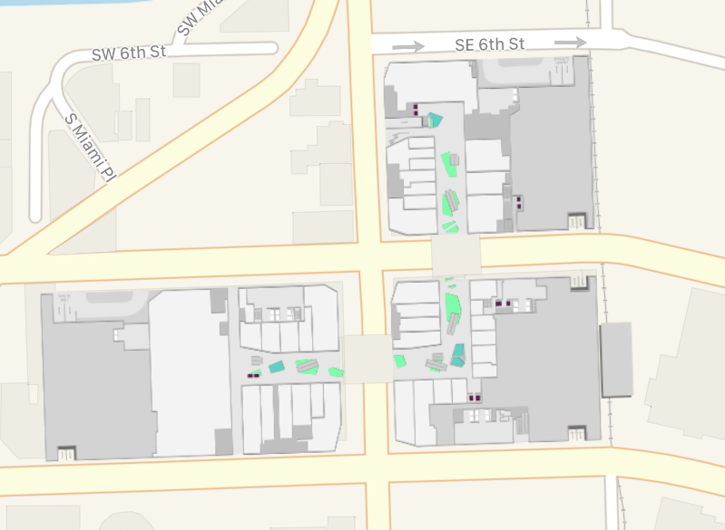
  - Option 1 | First Floor Entrance. If you utilize the first option and enter from the ground floor lobby located at 78 SW 7th St and South Miami Avenue, the entrance is just across the street from River Oyster bar and Brickell Smoke Shop on SW 7th Street. There is also a grey sign just outside of the lobby that says BCC Tower 2 (indicated by the black circle). When you get to the lobby, you’ll head to the elevator bank and go to the 5th floor. When you get to WeWork on the 5th floor, check-in with the front desk receptionist, tell them you are here for a meeting with CORPlaw, and then a member of our team will come down to greet you.
Saks Fifth Avenue

SW 7th Street

SW 8th Street

  - Option 2 | 2nd or 3rd Floor Entrance. The other option is if you to enter through the BCC shopping mall entrance (you’ll know you are in the mall because you’ll be surrounded by high-end shops) on the 2nd or 3rd floor towards the Saks Fifth Avenue side of the mall. Head to the elevator bank and go to the 5th floor. When you get to WeWork on the 5th floor, check-in with the front desk receptionist, tell them you are here for a meeting with CORPlaw, and then a member of our team will come down to greet you. Below is how the elevator bank looks from the 2nd and 3rd Floor.
Floor 3
(Enter here then take the elevator to floor 5)

Floor 2
(Enter here then take the elevator to floor 5)

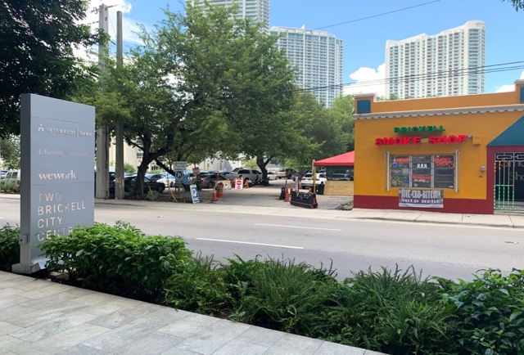
Where can I park? In terms of parking Downtown, be sure to add on extra 15 minutes to your commute. In Downtown there are a few parking options: nearby parking garages, street parking (if you can find it), and street parking lots. Here are two convenient options we’ve highlighted for your convenience:

- Parking Lot on SW 7th Street. The parking lot on SW 7th Street is located directly across the BCC Tower 2 and the WeWork office, providing easy access to the CORPlaw office. If you see the Brickell Smoke Shop, then you know you’re in the right place.
SW 7th Street

Rate. Parking is available in the 7th Street Lot for a flat rate of $15.00.

- Brickell City Centre Parking Garage.
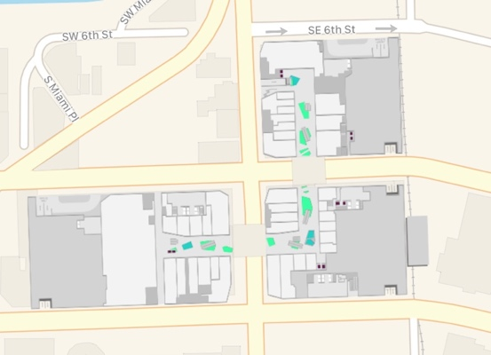
There are multiple entrances to the valet/parking garages at BCC. The closest entrance to the CORPlaw office (indicated by the black circle) would be the parking garage entrance (indicated by the red circle) located on the west side of SW 7th Street. Stay on the left lane for easy access.
SW 7th Street

Saks Fifth Avenue

Rates. Parking rates for the Garage are as follows:
0 to 4 hours $10 | 6 to 7 hours $25
4 to 5 hours $15 | 7 to 8 hours $30
5 to 6 hours $20 | 8 to 24 hours $40
SW 8th Street

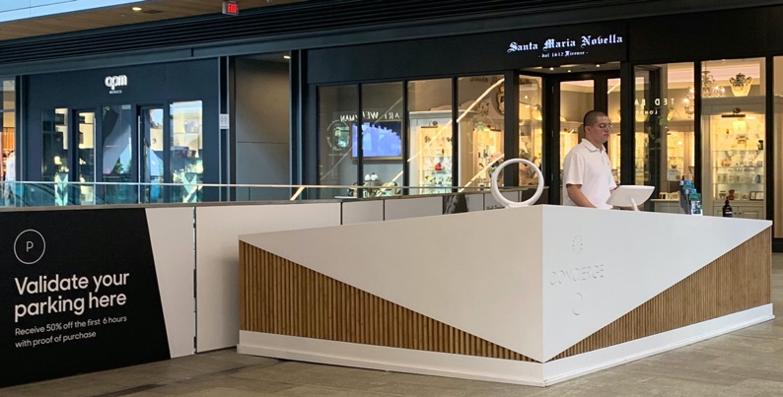
  - Parking Validation. Parking validation is available at the concierge during regular store hours on Level 2, B block near the store Santa Maria Nobella. Validation is applicable for 50% off the first 6 hours of parking with proof of purchase.

- What do I do when I arrive at WeWork?
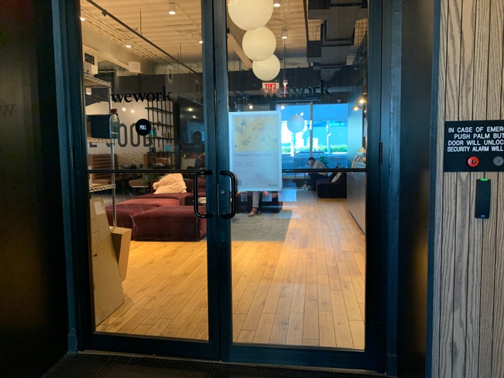
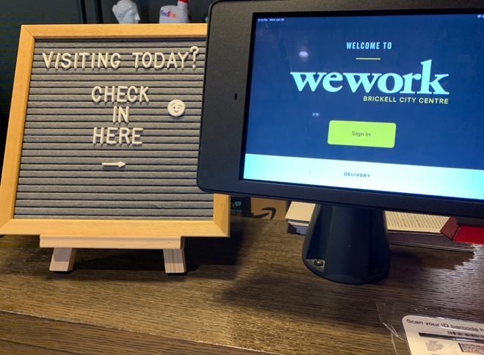
  - Walk into WeWork Office on the 5th floor, check in at the front desk by inputting your details into the tablet on the desk, then wait in the lobby for a CORPlaw member to greet you. Feel free to enjoy some water or coffee at your convenience.

Entrance to WeWork Lobby
(WeWork BCC 5th Floor)

WeWork Front Desk Check-in
(WeWork BCC 5th Floor)

Follow us on social media!
@CORPlawfirm
@CORPlaw
@CORPlaw-us

Love the WeWork space? So do we!
Tag us on social media during your visit and follow us for access to free giveaways!

